|  |  |  |  |
| --- | --- | --- | --- |
| **Name of Student: NINAD AVINASH PATIL** | | | |
| **Roll No: 33** | | **Lab Practical Number: 5(D)** | |
| **Title of Lab Practical: D. JQUERY and Database Connectivity**  **1. Create an ASP .NET web page to display HTML table. Use jQuery to fetch data from backend and display it on to HTML page.** | | | |
| **DOP: 21/04/2021** | | **DOS: 27/04/2021** | |
| **CO Mapped: CO1** | **PO Mapped: PO3, PO5, PO7,**  **PO12, PSO1, PSO2** | **Faculty Signature:** | **Marks:** |

**Practical No 5(D)**

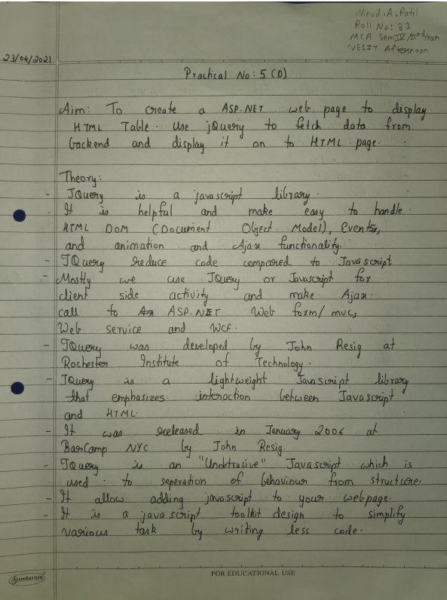

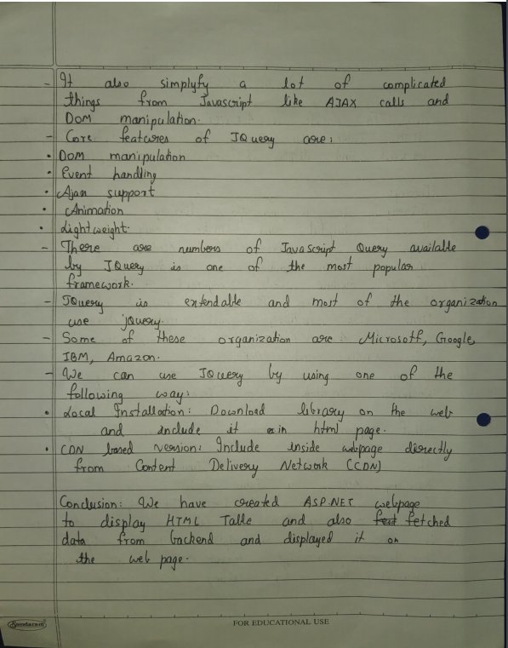

**Code:**

**WebService1.asmx**

using System;

using System.Collections.Generic;

using System.Linq;

using System.Web;

using System.Web.Services;

using System.Data;

using System.Data.SqlClient;

using System.Configuration;

using System.Web.Script.Serialization;

namespace P5D

{

/// <summary>

/// Summary description for WebService1

/// </summary>

[WebService(Namespace = "http://tempuri.org/")]

[WebServiceBinding(ConformsTo = WsiProfiles.BasicProfile1_1)]

[System.ComponentModel.ToolboxItem(false)]

// To allow this Web Service to be called from script, using ASP.NET AJAX, uncomment the following line.

// [System.Web.Script.Services.ScriptService]

public class WebService1 : System.Web.Services.WebService {

[WebMethod]

public void GetAllEmployee() {

List<Employee> employeelist = new List<Employee>();

string CS = ConfigurationManager.ConnectionStrings["DBCS"].ConnectionString;

using (SqlConnection con = new SqlConnection(CS)) {

SqlCommand cmd = new SqlCommand("spGetAllEmployee", con);

cmd.CommandType = CommandType.StoredProcedure;

con.Open();

SqlDataReader rdr = cmd.ExecuteReader();

while (rdr.Read()) {

Employee employee = new Employee();

employee.EmpId = Convert.ToInt32(rdr["EmpId"]);

employee.EmpName = rdr["EmpName"].ToString();

employee.EmpSal = Convert.ToInt32(rdr["EmpSal"]);

employee.EmpJob = rdr["EmpJob"].ToString();

employee.EmpDeptNo = rdr["EmpDeptNo"].ToString();

employeelist.Add(employee);

} }

JavaScriptSerializer js = new JavaScriptSerializer();

Context.Response.Write(js.Serialize(employeelist));

} } }

**WebForm1.aspx**

<%@ Page Language="C#" AutoEventWireup="true" CodeBehind="WebForm1.aspx.cs" Inherits="P5D.WebForm1" %>

<!DOCTYPE html PUBLIC "-//W3C//DTD XHTML 1.0 Transitional//EN" "http://www.w3.org/TR/xhtml1/DTD/xhtml1-transitional.dtd">

<html xmlns="http://www.w3.org/1999/xhtml">

<head runat="server">

<link rel="stylesheet" href="https://maxcdn.bootstrapcdn.com/bootstrap/4.0.0/css/bootstrap.min.css">

<script src="https://ajax.googleapis.com/ajax/libs/jquery/3.3.1/jquery.min.js"></script>

<script src="https://maxcdn.bootstrapcdn.com/bootstrap/4.0.0/js/bootstrap.min.js"></script>

<title>JQUERY and Database Connectivity</title>

</head>

<script type="text/javascript">

$(document).ready(function () {

$.ajax({

url: 'WebService1.asmx/GetAllEmployee',

dataType: "json",

method: 'post',

success: function (data) {

var employeeTable = $('#tblEmployee tbody');

employeeTable.empty();

$(data).each(function (index, emp) {

employeeTable.append('<tr><td>' + emp.EmpId + '</td><td>'

+ emp.EmpName + '</td><td>' + emp.EmpSal + '</td><td>' + emp.EmpJob

+ '</td><td>' + emp.EmpDeptNo + '</td></tr>');

}); },

error: function (err) {

alert(err);

} }); });

</script>

<body>

<form id="form1" runat="server">

<div class="container">

<h3 class="text-uppercase text-center">Employee Details</h3>

<table id="tblEmployee" class="table table-bordered">

<thead class="bg-dark text-white">

<tr>

<th>Employee ID</th>

<th>Employee Name</th>

<th>Employee Salary</th>

<th>Employee Job</th>

<th>Employee DeptNo</th>

</tr>

</thead>

<tbody></tbody>

</table>

</div>

</form>

</body>

</html>

**Employee.cs**

using System;

using System.Collections.Generic;

using System.Linq;

using System.Web;

namespace P5D

{

public class Employee {

public int EmpId { get; set; }

public string EmpName { get; set; }

public int EmpSal { get; set; }

public string EmpJob { get; set; }

public string EmpDeptNo { get; set; }

} }

**Web.config**

<?xml version="1.0"?>

<!--

For more information on how to configure your ASP.NET application, please visit

http://go.microsoft.com/fwlink/?LinkId=169433

-->

<configuration>

<connectionStrings>

<add name="ApplicationServices"

connectionString="data source=.\SQLEXPRESS;Integrated Security=SSPI;AttachDBFilename=|DataDirectory|\aspnetdb.mdf;User Instance=true"

providerName="System.Data.SqlClient" />

<add name="DBCS" connectionString="data source=NINAD\SQLEXPRESS; database=student; integrated security=true;"/>

</connectionStrings>

<system.web>

<compilation debug="true" targetFramework="4.0" />

<authentication mode="Forms">

<forms loginUrl="~/Account/Login.aspx" timeout="2880" />

</authentication>

<membership>

<providers>

<clear/>

<add name="AspNetSqlMembershipProvider" type="System.Web.Security.SqlMembershipProvider" connectionStringName="ApplicationServices"

enablePasswordRetrieval="false" enablePasswordReset="true" requiresQuestionAndAnswer="false" requiresUniqueEmail="false"

maxInvalidPasswordAttempts="5" minRequiredPasswordLength="6" minRequiredNonalphanumericCharacters="0" passwordAttemptWindow="10"

applicationName="/" />

</providers>

</membership>

<profile>

<providers>

<clear/>

<add name="AspNetSqlProfileProvider" type="System.Web.Profile.SqlProfileProvider" connectionStringName="ApplicationServices" applicationName="/"/>

</providers>

</profile>

<roleManager enabled="false">

<providers>

<clear/>

<add name="AspNetSqlRoleProvider" type="System.Web.Security.SqlRoleProvider" connectionStringName="ApplicationServices" applicationName="/" />

<add name="AspNetWindowsTokenRoleProvider" type="System.Web.Security.WindowsTokenRoleProvider" applicationName="/" />

</providers>

</roleManager>

</system.web>

<system.webServer>

<modules runAllManagedModulesForAllRequests="true"/>

</system.webServer>

</configuration>

**Database Table:**

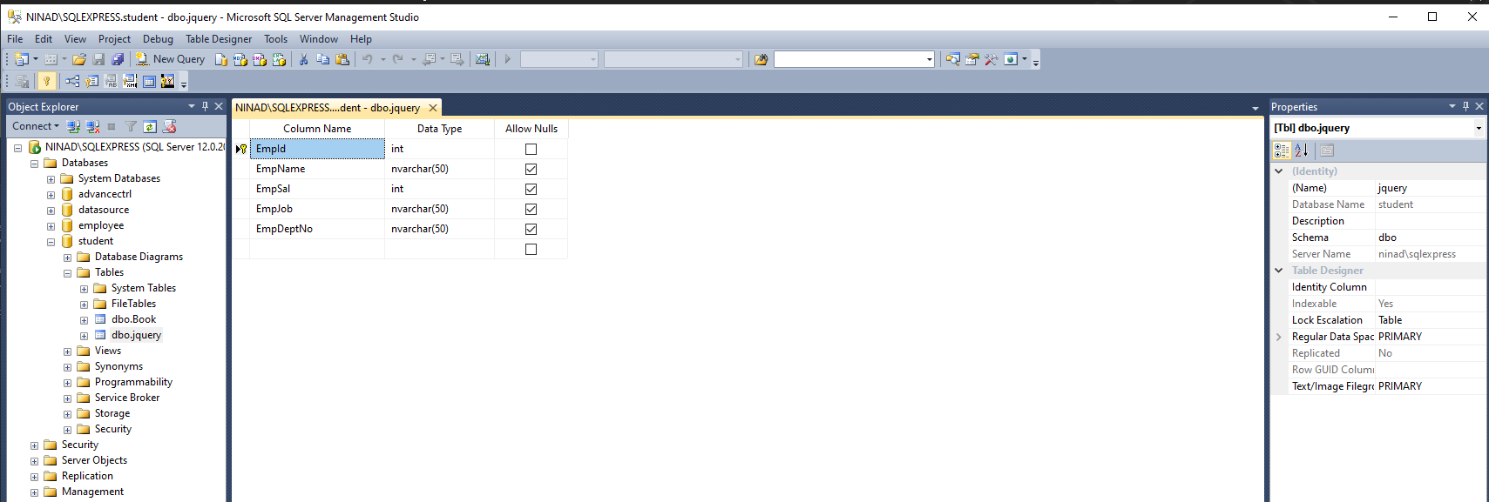

**Stored Procedures:**

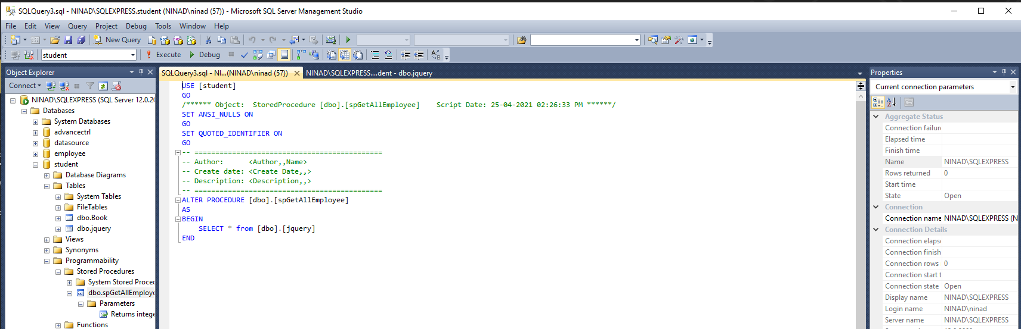

**Output:**

